# EARTHQUAKEPREDICTIONMODELUSINGPYTHON

BATCHMEMBER

TEAM-ID : Proj_272172_Team_2 950621104106:R.Thanga Navitha

Phase5SubmissionDocument

**ProjectTitle:**EarthquakePredictionModelUsingPython.

**Phase3:**ProjectDocumentation&Submission.

**Topic:**Inthissectionyouwilldocumentthecompleteprojectandprepareit for submission.

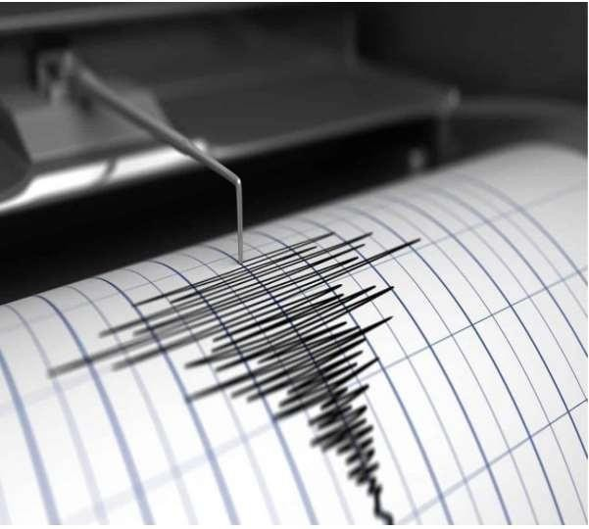

# EARTHQUAKEPREDICTION

### Introduction:

* Earthquake prediction is a branch of the science of seismology that aims to specifythetime,location,andmagnitudeoffutureearthquakeswithincertain limits.
* Itisdifferentfromearthquakeforecasting,whichistheprobabilisticassessment of general earthquake hazard in a given area over a longperiod of time.
* Itis alsodifferent fromearthquakewarning systems, whichprovideareal-time alertofsecondstoneighboringregionsthatmightbeaffectedbyanearthquake.
* Earthquakepredictionisachallengingandcontroversialtopic,asthereisno reliable method to predict earthquakes with high accuracy and precision.
* Manypossible earthquake precursors have beenproposed, suchas changes in seismicitypatterns,grounddeformation,electromagneticsignals,geochemical anomalies, and animal behavior, but none of them have been proven to be consistent and reliable across different regions and scales.
* Somescientistsareoptimisticthatwithmoreresearchanddata,predictionmight be possible, while others are pessimistic and argue that earthquake prediction is inherently impossible.
* Predictioncanbe furtherdistinguishedfrom[earthquakewarningsystems](https://en.wikipedia.org/wiki/Earthquake_warning_system),which, upon detection of an earthquake, provide a real-time warning of seconds to neighboring regions that might be affected.
* Earthquakepredictionissometimesdistinguishedfrom[earthquakeforecasting](https://en.wikipedia.org/wiki/Earthquake_forecasting), which can be defined as the probabilistic assessment of *general* earthquake hazard, including the frequency and magnitude of damaging earthquakes in a given area over years or decades.
* Notallscientistsdistinguish"prediction"and"forecast",butthedistinctionis useful.
* Extensive searches have reported many possible earthquake precursors, but, so far,suchprecursorshavenotbeenreliablyidentifiedacrosssignificantspatialand temporal scales.

### DataSource:

Agooddatasourceforearthquakepredictionusingmachinelearningshouldbe accurate time, location, depth, magnitude.

DatasetLink:(https://[www.kaggle.com/datasets/usgs/earthquake-database)](http://www.kaggle.com/datasets/usgs/earthquake-database))

### Givendataset:

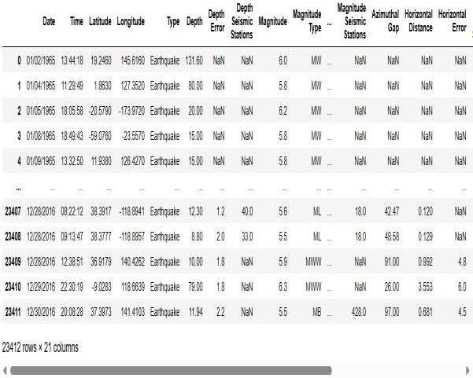

*Here’salistoftoolsandsoftwarecommonlyusedintheprocess:*

### ProgrammingLanguage:

-Pythonisthemostpopularlanguageformachinelearningdueto its extensive libraries and frameworks. You can use libraries like numpy, pandas, scikit-learn, and more.

### IntegratedDevelopmentEnvironment(IDE):

-Choose anIDEforcodingandrunning machine learningexperiments. Somepopularoptions includeJupyterNotebook,GoogleColab,ortraditional IDEs like PyCharm.

### MachineLearningLibraries:

* You'llneedvariousmachinelearninglibraries,including:
  + scikit-learnforbuildingandevaluatingmachinelearningmodels.
  + TensorFloworPyTorchfordeeplearning,ifneeded.
  + XGBoost,LightGBM,orCatBoostforgradientboostingmodels.

### DataVisualizationTools:

-ToolslikeMatplotlib,Seaborn,orPlotlyareessentialfordata exploration and visualization.

### DataPreprocessingTools:

-Librarieslikepandashelpwithdatacleaning,manipulation,and preprocessing.

### DataCollectionandStorage:

-Dependingonyourdatasource,youmight needwebscrapingtools or databases for data storage.

### VersionControl:

* + VersioncontrolsystemslikeGitarevaluablefortracking changes in your code and collaborating with others.

### NotebooksandDocumentation:

* + Toolsfordocumentingyourwork,suchasJupyterNotebooksor Markdown for creating *README* files and documentation.

### HyperparameterTuning:

* + ToolslikeGridSearchCVorRandomizedSearchCVfromscikit- learn can help with hyperparameter tuning.

### WebDevelopmentTools(forDeployment):

* + If you plan to create a web application for model deployment, knowledge of web development tools like *Flask or Django* for backend development, and *HTML, CSS, and JavaScript* for the front-end canbe useful.

### CloudServices(forScalability):

* + Forlarge-scaleapplications,cloudplatformslikeAWS,GoogleCloud,or

Azurecanprovidescalablecomputingandstorageresources.

### ExternalDataSources(ifapplicable):

* + Dependingonyourproject'sscope,youmightrequiretoolstoaccess external data sources, such as APIs or data scrapingtools.

### DataAnnotationandLabelingTools(ifapplicable):

* + Forspecializedprojects,toolsfordataannotationand labeling may be necessary, such as Labelbox orSupervisely.

### GeospatialTools(forlocation-basedfeatures):

* + Ifyourdatasetincludesgeospatialdata,geospatiallibrarieslike GeoPandas can be helpful.

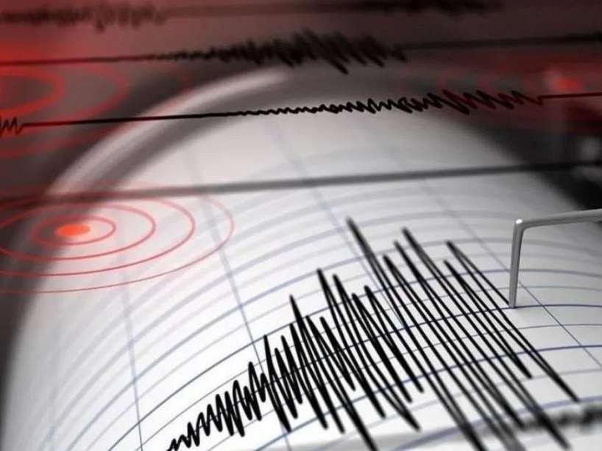

# 1.DESIGNTHINKINGANDPRESENTINFORMOF DOCUMENT

### Empathize:

* + Understandtheneedsandchallengesofallstakeholdersinvolvedinthe earthquake prediction process
  + Conduct interviews and surveys to gather insights on what users value in propertyvaluationandwhatinformationismostcriticalfortheirdecision- making.

### Define:

* + Clearlyarticulatetheproblemstatement,suchas"Howmightwepredict earthquake more accurately and transparently using machine learning?"
  + Identifythekeygoalsandsuccesscriteriafortheproject,suchasincreasing prediction accuracy, reducing bias, or improving user trust in the valuation process.

## Ideate:

* + Brainstormcreativesolutionsanddatasourcesthatcanenhancethe accuracy and transparency of earthquake predictions.
  + Encourageinterdisciplinarycollaborationtogenerateawiderangeofideas, including the use of alternative data, new algorithms, or improved visualization techniques.

### Prototype:

* + Createprototypemachinelearningmodelsbasedontheideas generated during the ideation phase.
  + Testanditerateontheseprototypestodeterminewhichapproachesaremost promising in terms of accuracy and usability.

### Test:

* + Gatherfeedbackfromusersandstakeholdersbytestingthemachine learning models with real-world data and scenarios.
  + Assesshowwellthemodelsmeetthedefinedgoalsandsuccess criteria, and make adjustments based on user feedback.

### Implement:

* + Develop a production-ready machine learning solution for predicting earthquake,integratingthebest-performingalgorithmsanddatasources.
  + Implementtransparencymeasures,suchasmodelinterpretabilitytools, to ensure users understand how predictions are generated.

### Evaluate:

* + Continuouslymonitortheperformanceofthemachinelearning model after implementation to ensure it remains accurate.
  + Gatherfeedbackandinsightsfromusers.

### Iterate:

* + Applyaniterativeapproachtorefinethemachinelearningmodelbased on ongoing feedback and changing user needs.
  + Continuouslyseekwaystoenhancepredictionaccuracy, transparency, and user satisfaction.

### ScaleandDeploy:

* + Oncethemachinelearningmodelhasbeenoptimizedandvalidated, deploy it .
  + Ensurethemodelisaccessiblethroughuser-friendlyinterfacesand integrates seamlessly into real estate workflows.

### EducateandTrain:

* + Providetrainingandeducationalresourcestohelpusersunderstandhow the machine learning model works, what factors it considers, and its limitations.
  + Fosteracultureofdataliteracyamongstakeholderstoenhancetrustinthe technology.

# DESIGNINTOINNOVATION

### DataCollection:

Gatheracomprehensivedatasetthatincludesfeaturessuchaslatitude, longitude, magnitude, depth, others relevant variables.

### DataPreprocessing:

Cleanthedatabyhandlingmissingvalues,outliers,andencoding categorical variables. Standardize or normalize numerical features as necessary.

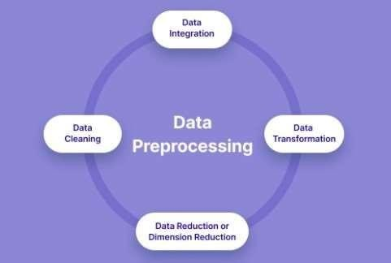

# PYHONPROGRAM:

##### #Importnecessarylibraries

importpandasaspd

fromsklearn.model_selectionimporttrain_test_split from sklearn.preprocessing import LabelEncoder from sklearn.impute import SimpleImputer

fromsklearn.preprocessingimportStandardScaler

*#Loadthedataset(replace'earthquake.csv'withyourdatasetfile)*

df=pd.read_csv('C:/Users/barat/Downloads/archive/database.csv')

*#Displaythefirstfewrowsofthedatasettogetanoverview*

print("DatasetPreview:") print(data.head())

#DataPre-processing

##### #HandleMissingValues

*#Let'sfillmissingvaluesinnumericcolumnswiththemeanandin categorical columns with the most frequent value.*

numeric_cols=data.select_dtypes(include='number').columnscategorical_cols= data.select_dtypes(exclude='number').columns

imputer_numeric=SimpleImputer(strategy='mean')imputer_categorical= SimpleImputer(strategy='most_frequent')

data[numeric_cols] = imputer_numeric.fit_transform(data[numeric_cols]) data[categorical_cols] =

imputer_categorical.fit_transform(data[categorical_cols])

##### #ConvertCategoricalFeaturestoNumerical

*# We'lluseLabelEncodingforsimplicityhere.You canalsouseone- hot encoding for nominal categorical features.*

label_encoder=LabelEncoder()for col in categorical_cols:

data[col]=label_encoder.fit_transform(data[col])

##### #SplitDataintoFeatures(X)&Target(y)

X=data.drop(columns=[Magnitude]) y = data['Magnitude']

##### #NormalizetheData

scaler=StandardScaler()X_scaled= scaler.fit_transform(X)

##### #Splitdataintotrainingandtestingsets

X_train,X_test,y_train,y_test=train_test_split(X_scaled,y,test_size=0.2, random_state=42)

*#Displaythepreprocesseddata*

print("\nPreprocessed Data:") print(X_train[:5]) print(y_train[:5])

### FeatureEngineering:

Createnewfeaturesortransformexistingonestoextract morevaluable information.

### ModelSelection:

Choosetheappropriatemachinelearningmodelforthetask.Common models for regression problems like house price prediction include *Linear Regression, Decision Trees, Random Forest, Gradient Boosting, and Neural Networks.*

### Training:

Splitthedatasetintotrainingandtestingsetstoevaluatethemodel's performance. Consider techniques like cross-validation to prevent overfitting.

### HyperparameterTuning:

Optimize the model's hyperparameters to improve its predictive accuracy.Techniqueslike gridsearchorrandomsearchcanhelpwiththis.

### EvaluationMetrics:

Selectappropriateevaluationmetricsforregressiontasks,suchas *Mean Absolute Error (MAE), Mean Squared Error (MSE), or Root Mean Squared Error (RMSE)*. Choose the metric that aligns with the specific objectives of your project.

### Regularization:

ApplyregularizationtechniqueslikeL1(Lasso)orL2(Ridge) regularization to prevent overfitting.

### FeatureSelection:

Usetechniqueslikefeatureimportancescoresorrecursivefeature elimination to identify the most relevant features for the prediction.

### Interpretability:

Ensurethatthemodel'spredictionsareinterpretableandexplainable.

Thisisespeciallyimportantforearthquakeapplicationswherestakeholderswant to understand the factors affecting predictions.

### Deployment:

Developauser-friendlyinterfaceorAPIforend-userstoinputproperty details and receive price predictions.

### ContinuousImprovement:

Implementafeedbackloopforcontinuousmodelimprovementbased on user feedback and new data.

### EthicalConsiderations:

Bemindfulofpotentialbiasesinthedataand model.Ensurefairness and transparency in your predictions.

### MonitoringandMaintenance:

Regularlymonitorthemodel'sperformanceintherealworldandupdateit as needed.

### Innovation:

ConsiderinnovativeapproachessuchasusingsatelliteimageryorIoTdata for real-time property condition monitoring.

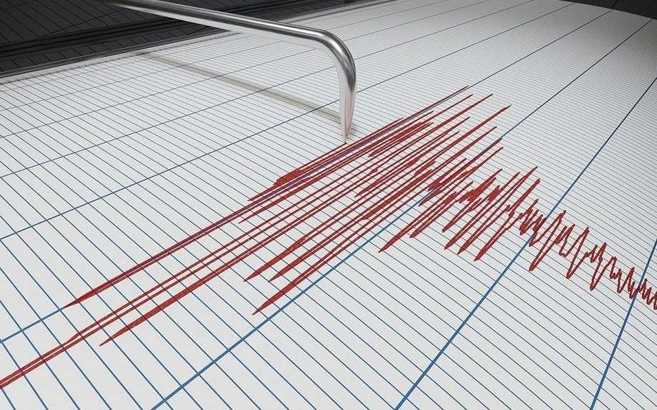

# BUILDLOADINGANDPREPROCESSINGTHEDATASET

### DataCollection:

Obtain a dataset that contains information about earthquake and theircorrespondingprices.Thisdatasetcanbeobtainedfromsourceslikereal estate websites, government records, or other reliable data providers.

### LoadtheDataset:

* + - Importrelevantlibraries,suchaspandasfordatamanipulationand numpy for numerical operations.
    - LoadthedatasetintoapandasDataFrameforeasydatahandling.
    - Youcanuse*pd.read_csv()*forCSVfilesorotherappropriate functions for different file formats.

## Program:

importpandasaspd importnumpyasnp

importseabornassns

importmatplotlib.pyplotasplt

fromsklearn.model_selectionimporttrain_test_splitfrom sklearn.preprocessing import StandardScaler

from sklearn.metrics import r2_score, mean_absolute_error,mean_squared_error

fromsklearn.linear_modelimportLinearRegressionfrom sklearn.linear_model import Lasso

fromsklearn.ensembleimportRandomForestRegressorfrom sklearn.svm import SVR

#### LoadingDataset:

df=pd.read_csv(“C:/Users/barat/Downloads/archive/databa se.csv'”)

### Output:



* 1. **DataExploration:**

Explorethedatasettounderstanditsstructureandcontents.Check forthe presence ofmissingvalues,outliers,anddatatypesofeachfeature.

### DataCleaning:

Handle missingvaluesbyeitherremovingrowswithmissingdataor imputing values based on the nature of the data.

### FeatureSelection:

Identifyrelevantfeaturesforearthquakeprediction.Featureslikethe latitude, longitude, magnitude, and depth are often important.

##### #Checkingformissingvalues

**In[1]:**

print("Missingvalues") print("-" *30) print(df.isna().sum()) print("-"*30)

print("Totalmissingvalues",df.isna().sum().sum())

### Out[1]:

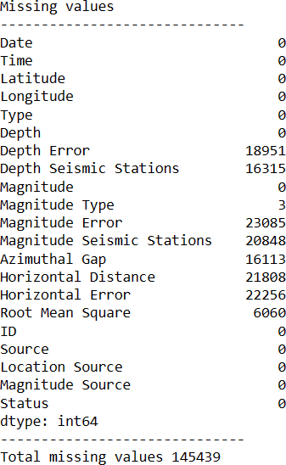

* 1. **FeatureEngineering:**

Createnewfeaturesortransformexistingonestocaptureadditional information that may impact earthquake.

### DataEncoding:

Convertcategoricalvariablesintonumericalformatusing techniques like one-hot encoding.

### Train-TestSplit:

Splitthedatasetintotrainingandtestingsetstoevaluatethe

machinelearningmodel'sperformance.

### Program:

X=df[['Latitude','Longitude']] y = df[['Depth', 'Magnitude']]

X_train,X_test,y_train,y_test=train_test_split(X,y,test_size=0.2,random_state=42)

# PERFORMING DIFFERENT ACTIVITIES LIKEFEATUREENGINEERING,MODELTRAINING,

## EVALUATIONetc.,

### FeatureEngineering:

* + - Asmentionedearlier,featureengineeringiscrucial.Itinvolves creatingnewfeaturesortransformingexistingonestoprovide meaningful information for your model.
    - Extracting informationfrom textualdescriptions.

### DataPreprocessing&Visualisation:

Continuedatapreprocessingbyhandlinganyremainingmissing values or outliers based on insights from your data exploration.

#### VisualisationandPre-ProcessingofData:

**In[1]:**

sns.histplot(df,x = 'Latitude', bins=50, color='y') sns.histplot(df,x='Longitude',bins=50,color='g') plt.xlabel('Latitude & Longitude')

**Out[1]:**

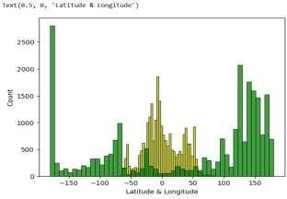

**In[2]:**

sns.boxplot(df,x='Latitude',palette='Blues') sns.boxplot(df,x='Longitude',palette='Blues') plt.xlabel('Latitude & Longitude')

**Out[2]:**

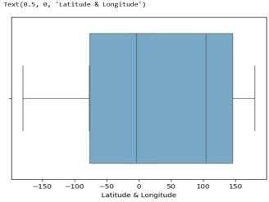

**In[3]:**

sns.jointplot(df,x='Latitude',y='Magnitude',kind='hex',color='pink') sns.jointplot(df,x='Longitude', y='Depth', kind='hex', color='green')

**Out[3]:**

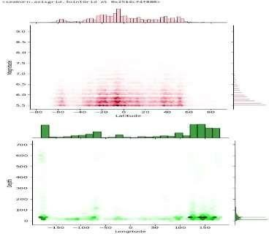

**In[4]:**

sns.jointplot(df,x='Latitude', y='Depth', color='orange') sns.jointplot(df,x='Longitude', y='Magnitude', color='red')

**Out[4]:**

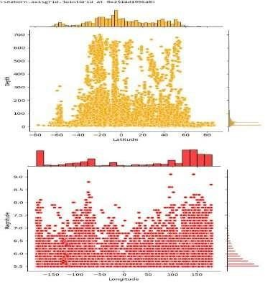

**In[5]:**

plt.figure(figsize=(6,8)) sns.pairplot(df) plt.show()

**Out[5]:**

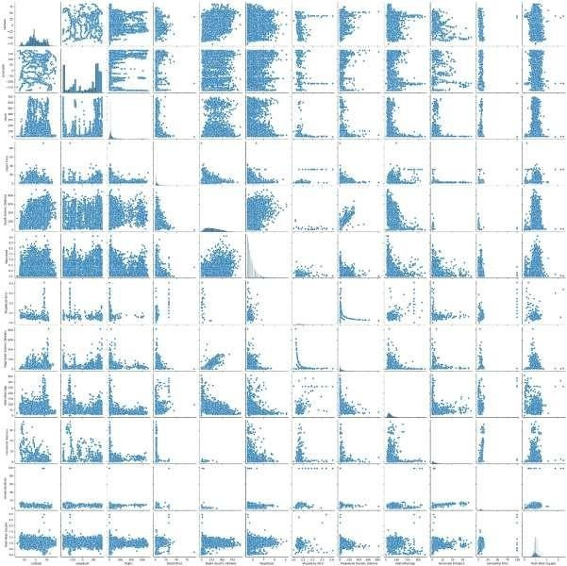

**In[6]:**

df.hist(figsize=(10,8))

**Out[6]:**

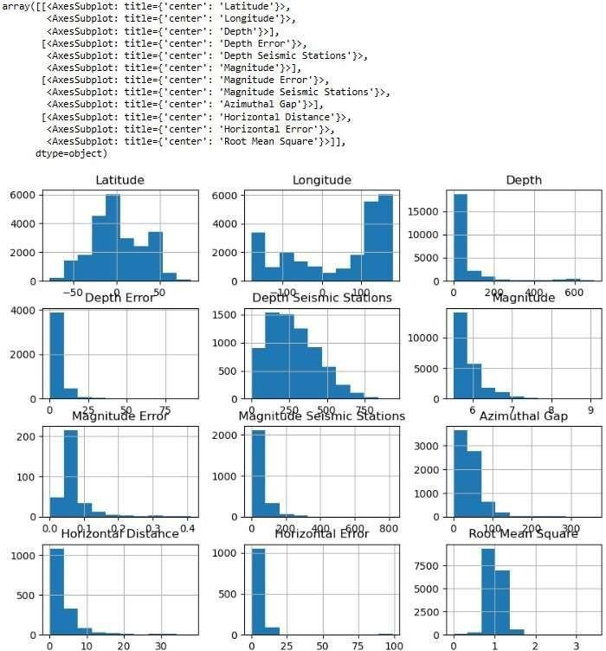

**In[7]:**

df.corr(numeric_only=True)

**Out[7]:**

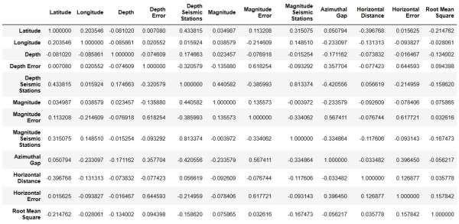

**In[8]:**

plt.figure(figsize=(10,5)) sns.heatmap(df.corr(numeric_only= True),annot = True) plt.show()

**Out[8]:**

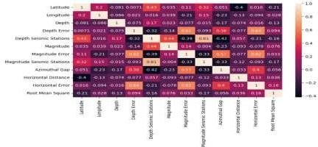

### ModelSelection:

Chooseanappropriatemachinelearningmodelforyour regression task. *Common choices include:*

* + - LinearRegression
    - DecisionTrees
    - RandomForest

### Program:

importpandasaspdimport numpy as np import seaborn as sns

importmatplotlib.pyplotasplt

fromsklearn.model_selectionimporttrain_test_splitfrom sklearn.preprocessing import StandardScaler

from sklearn.metrics import r2_score, mean_absolute_error,mean_squared_error

fromsklearn.linear_modelimportElasticNet

fromsklearn.linear_modelimportLinearRegressionfrom sklearn.linear_model import Lasso

fromsklearn.ensembleimportRandomForestRegressorfrom sklearn.svm import SVR

#### LoadingDataset:

df=pd.read_csv(“C:/Users/barat/Downloads/archive/databa se.csv'”)

### Model1–LinearRegression

**In[1]:**

new_row={"Model":"Ridge","MAE":mae,"MSE":mse,"RMSE":rmse, "R2 Score": r_squared, "RMSE(Cross-Validation)":rmse_cross_val} models = models.append(new_row, ignore_index=True)

**In[2]:**

defevaluation(y_true,y_pred):

mae=mean_absolute_error(y_true,y_pred) mse = mean_squared_error(y_true, y_pred)

rmse=np.sqrt(mse)rmse_cross_val=np.mean(rmse) r_squared = r2_score(y_true, y_pred)

returnmae,mse,rmse,r_squared,rmse_cross_val

**In[3]:**

X_train,X_test,y_train,y_test=train_test_split(X,y,test_size=0.2,random_state=42) lin_reg = LinearRegression()

lin_reg.fit(X_train, y_train) predictions = lin_reg.predict(X_test)

mae,mse,rmse,r_squared,rmse_cross_val=evaluation(y_test,predictions) print("MAE:",mae)

print("MSE:",mse)

print("RMSE:",rmse) print("R2Score:",r_squared)

print("-"*30)

print("RMSECross-Validation:",rmse_cross_val)

**Out[3]:**

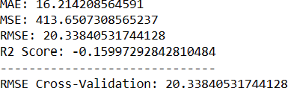

**EvaluationofPredictedData:**

**In[4]:**

plt.figure(figsize=(12,6)) plt.plot(np.arange(len(y_test)), y_test) plt.plot(np.arange(len(y_test)),predictions) plt.xlabel("Latitude & Longitude") plt.ylabel("Depth")

plt.title("ActualvsPrediction")

**Out[4]:**

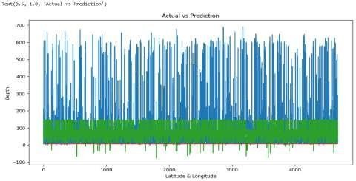

### Model2–LassoRegression

**In[1]:**

lasso = Lasso() lasso.fit(X_train, y_train)

predictions=lasso.predict(X_test)

mae,mse,rmse,r_squared,rmse_cross_val=evaluation(y_test,predictions) print("MAE:",mae)

print("MSE:",mse)

print("RMSE:",rmse) print("R2Score:",r_squared) print("-" *30)

print("RMSECross-Validation:",rmse_cross_val)

**Out[1]:**

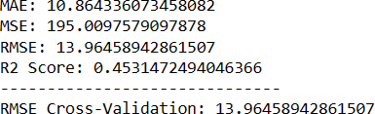

### Model3–ElasticNet

**In[1]:**

elasticnet = ElasticNet() elasticnet.fit(X_train, y_train) predictions=elasticnet.predict(X_test)

mae,mse,rmse,r_squared,rmse_cross_val=evaluation(y_test,predictions) print("MAE:",mae)

print("MSE:",mse)

print("RMSE:",rmse) print("R2Score:",r_squared) print("-" *30)

print("RMSECross-Validation:",rmse_cross_val)

**Out[1]:**

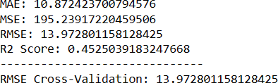

### Model4–SVR

**In[1]:**

svr=SVR(C=100000)

svr.fit(X_train,y_train) predictions=svr.predict(X_test)

mae,mse,rmse,r_squared,rmse_cross_val=evaluation(y_test,predictions) print("MAE:",mae)

print("MSE:",mse)

print("RMSE:",rmse) print("R2Score:",r_squared) print("-" *30)

print("RMSECross-Validation:",rmse_cross_val)

**Out[1]:**

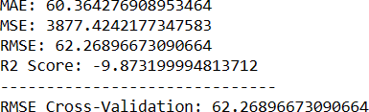

### Model5–RandomForestRegressor

**In[1]:**

random_forest=RandomForestRegressor(n_estimators=100) random_forest.fit(X_train, y_train)

predictions=random_forest.predict(X_test)

mae,mse,rmse,r_squared,rmse_cross_val=evaluation(y_test,predictions) print("MAE:",mae)

print("MSE:",mse)

print("RMSE:",rmse) print("R2Score:",r_squared) print("-" *30)

print("RMSECross-Validation:",rmse_cross_val)

**Out[1]:**

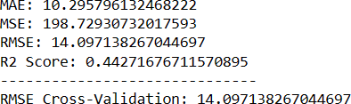

### Model6–PolynomialRegression(Degree=2)

**In[1]:**

poly_reg = PolynomialFeatures(degree =2) X_train_2d=poly_reg.fit_transform(X_train) X_test_2d = poly_reg.transform(X_test) lin_reg = LinearRegression() lin_reg.fit(X_train_2d, y_train)

predictions=lin_reg.predict(X_test_2d)

mae,mse,rmse,r_squared,rmse_cross_val=evaluation(y_test,predictions) print("MAE:",mae)

print("MSE:",mse)

print("RMSE:",rmse) print("R2Score:",r_squared) print("-" *30)

print("RMSECross-Validation:",rmse_cross_val)

**Out[1]:**

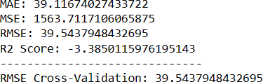

### Advantages:

* Itcanhelppeopleprepareforand mitigatethepotentialdamagesandlosses causedbyearthquakes. [Forexample,peoplecanevacuateareas,disconnectgas, electricity and water, organize and prepare evacuation centers, alertrelatives and authorities, and secure their belongings](https://earthspacesciences.weebly.com/uploads/2/0/2/9/20293403/evaluation_of_prediction.pps).
* It can help scientists and engineers better understand the causes, mechanisms, patterns, and effects of earthquakes. [For example, bymonitoring seismic activity and precursors, they can develop models andalgorithms for earthquake prediction and forecasting, identify locationswithin urban regions that are especially vulnerable to damaging earthquakegroundmotions(seismiczonation),andimprovethedesignandconstructionof earthquake-resistant structures](https://nap.nationalacademies.org/read/11327/chapter/6).
* It can help government agencies and authorities develop and implement policies and regulations related to earthquake risk management, disaster preparedness, response, and recovery. [For example, by providing reliableinformationandwarningsaboutearthquakehazardsandadvisories,theycanallocate resources and support for earthquake research and monitoringprograms, coordinate emergency services and relief efforts, and facilitateeconomic development and recovery of the affected areas](https://nap.nationalacademies.org/read/11327/chapter/6).

### Disadvantages:

* It is not a reliable or accurate method, as there is no proven way to predict earthquakes with high precision and certainty. Many possible earthquake precursorshavebeenproposed,butnoneofthemhavebeenconsistentlyand reliably identified across different regions and scales. There is also arisk of

falsealarmsormissedpredictionsthatcancausepanicorcomplacency among the public.

* It is not a cheap or easy method, as it requires a lot of resources and expertise to conduct extensive research and monitoring of seismic activity andprecursors.Italsoinvolvesalotofethicalandlegalissuesrelatedtothe responsibility and accountability of the predictors and the users of the predictions.
* Itis notasufficientoreffective method, asitdoes not guarantee thatpeople willactappropriatelyorrationally inresponsetothepredictions. There may be barriers or constraints that prevent people from taking preventive or protective measures, such as lack of awareness, education, trust, access, or resources.Theremayalsobeunintendedoradverseconsequencesthatresult from the predictions, such as social disruption, economic loss, or environmental damage.

### Conclusion:

* Earthquakepredictionisachallengingandimportanttaskthataimsto forecast the occurrence, location, magnitude, and impact of future earthquakes based on various types of data and models.
* Earthquakepredictioncanhelpreducethelossoflifeandproperty,improve the preparedness and resilience of communities, and advance the scientific understanding of the earth’s processes.
* However,earthquakepredictionisalsosubjecttomanyuncertainties, limitations, and ethical issues that need to be addressed.
* Earthquakedataisoftennoisy,incomplete,inconsistent,orunreliable.For example, seismic waveforms may be affected by environmental factors, instrument errors, or human interference.
* Earthquakecatalogmaybebiased,incomplete,orinaccurateduetodifferent reporting standards, detection thresholds, or measurement methods.
* Geologicalfeaturesmaybedifficulttomeasureorestimateduetothe complexity and variability of the earth’s structure and dynamics. Environmentalfactors maybeirrelevant,redundant,ormisleadingas potential precursors or indicators of seismic activity.
* Earthquake models are often based on simplifying assumptions, approximations,orempiricalrulesthatmaynotcapturethetruephysicsor statistics of the earthquake phenomenon.
* Earthquakepredictionisinherentlyprobabilisticanduncertainduetothe randomness and complexity of the earthquake process.
* Earthquakepredictionisnotaperfectsciencebutacontinuouslearning process that requires collaboration, innovation, and evaluation.
* Byimprovingthedataqualityandavailability,developingmorerealisticand robust models, enhancing the prediction accuracy and uncertainty quantification, and considering the ethical and social implications, earthquake prediction can become more feasible and beneficial for society.